Plot genomic region with SNPs genes and LD

This app can be used to create a plot that show a genomic region of interest with the SNPs and genes in that locus combined with the GWAS results. It can be used to communicate your results in a nice way, it is not recommended for exploring the data (so first find the locus you are interested in and then use this app to plot).

The application can be found here:

<http://icci-2:9100/plot_ld/>

In the first stage, the app search for all GAPIT outputs in a specified folder and will produce a table with each significant locus it founds, then in the next stage the user can choose a locus and produce the figure.

**IMPORTANT**: There are heavy calculations involve in the second stage and it can take some time to produce the output, so you need to be patient and to be careful with the size of region you choose (!).

Part I:  
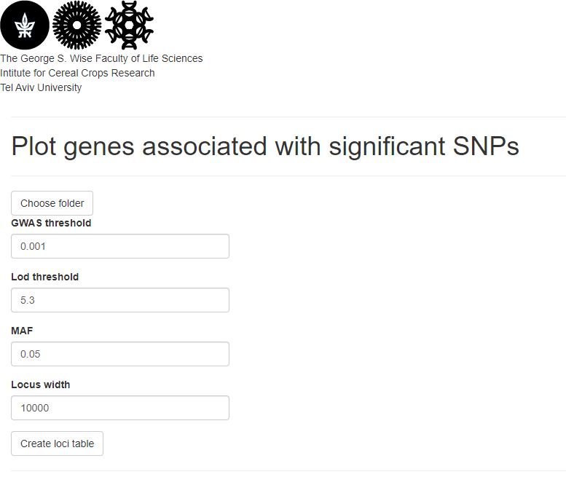Select a folder with GAPIT output, the P-value threshold, LOD threshold, minor allele frequency, and locus width.  
I recommend keeping all parameters as default at start, create the table and then change and re-create if you need.

Select GAPIT results folder from the server

Create the table

The folder needs to be in your file system on the ICCR server (could be the GAPIT output folder): 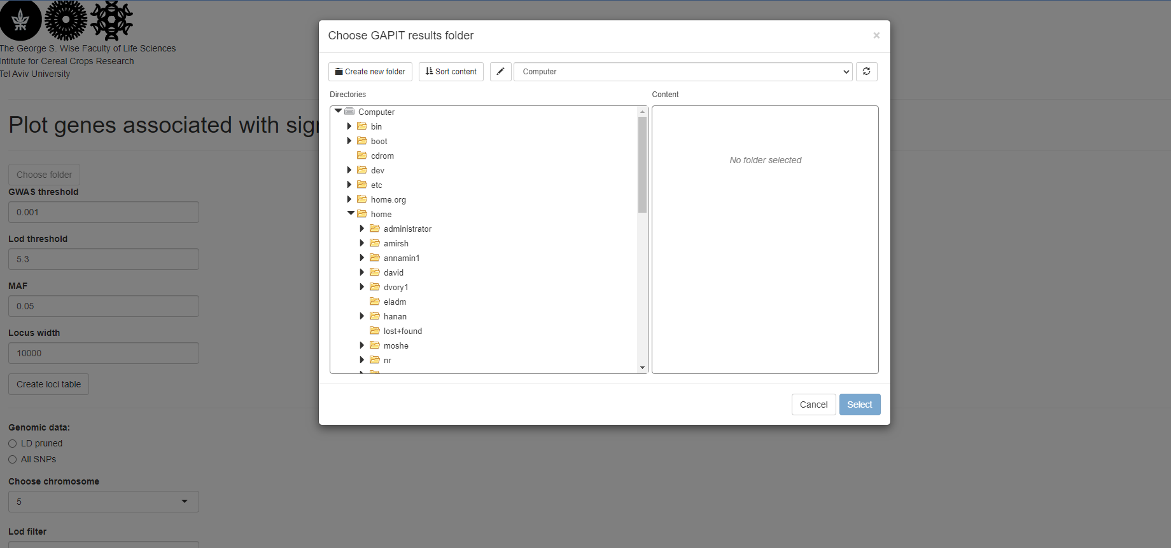

The loci table show the position, highest LOD score, genes in locus and the model,

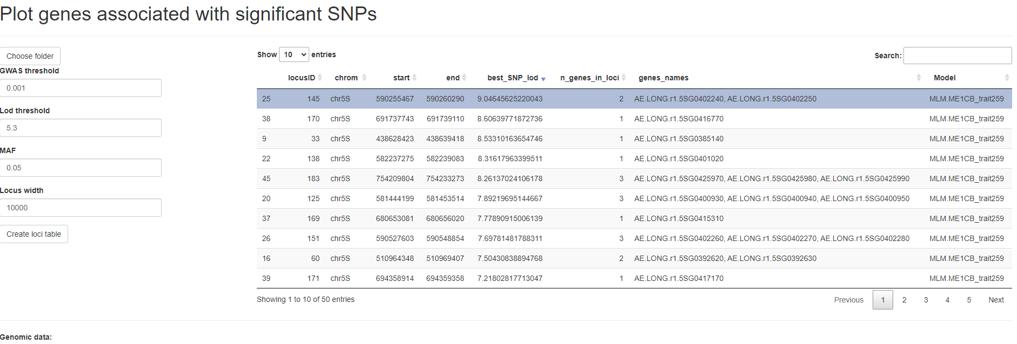You can sort or search the table to find the locus you are interested in.

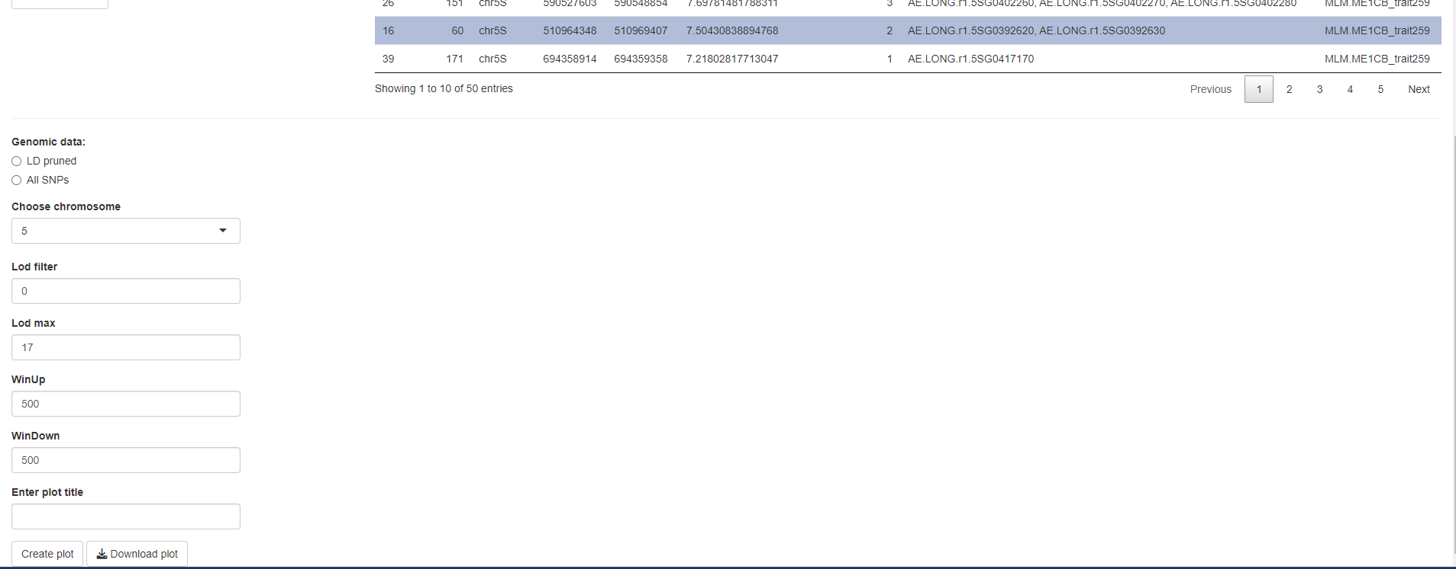Part II:  
When you find the locus you want to plot, select it on the table (it will be highlighted) and then choose the chromosome, the LOD parameters, the region to plot and a title (optional).

The amount of bp to add to the range in the table

The plot will show all SNPs and genes in range with notation for introns and exons.

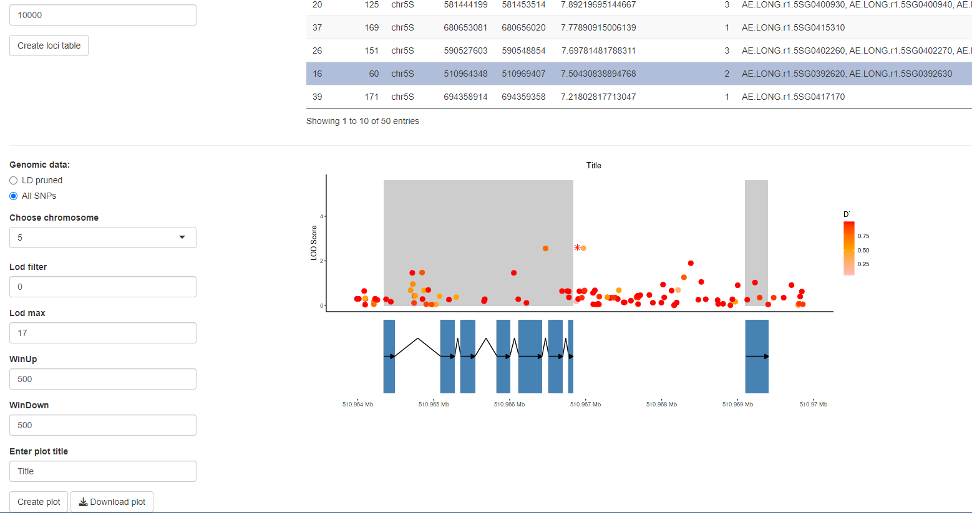Each SNP is colored according to the value of the LD between it and the most significant SNP, while the most significant SNP is marked with an asterisk.